1. **Create new records using CreateAPIView and APIView**

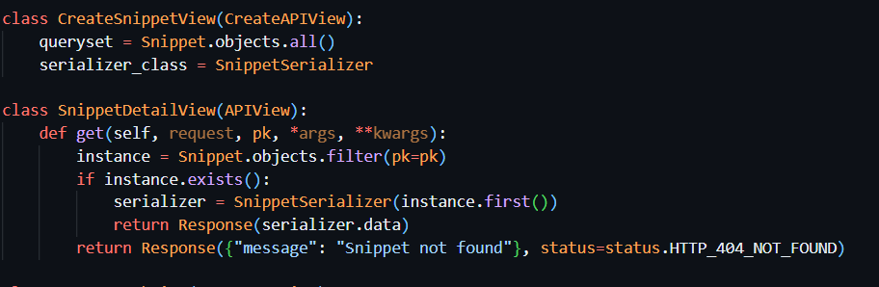

**CreateAPIView:**

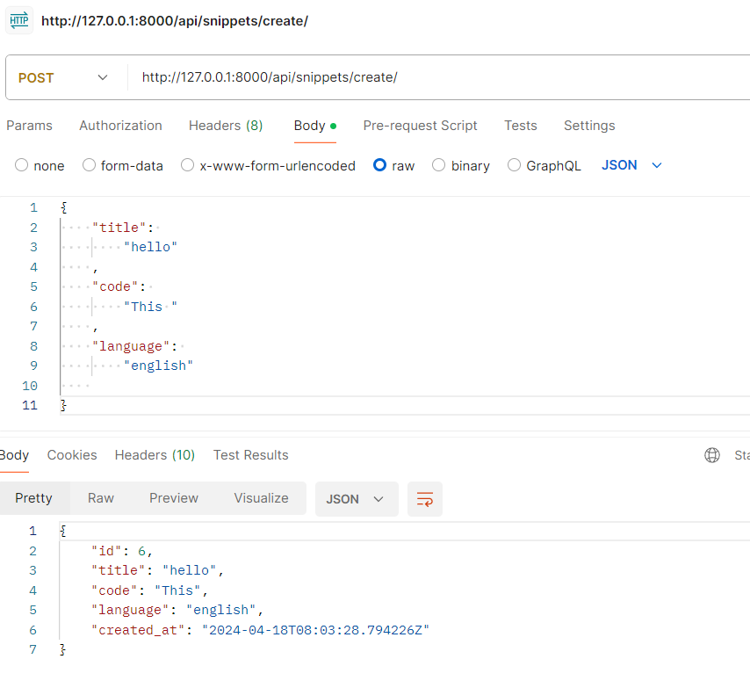

**APIVIEW:**

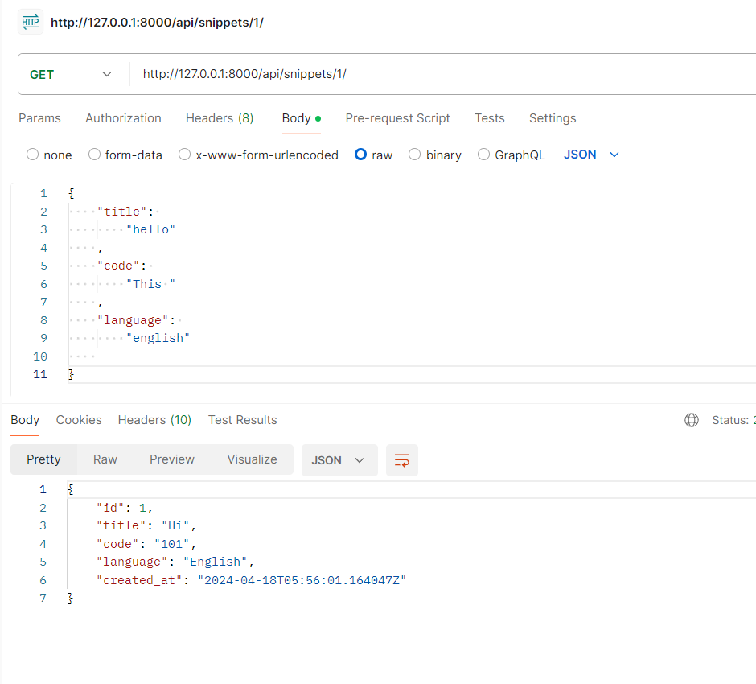

**2. Retrieve record details using RetrieveAPIView and APIView, considering foreign key fields.**

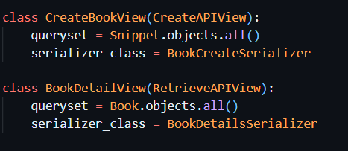

**RETRIVEAPIVIEW:**

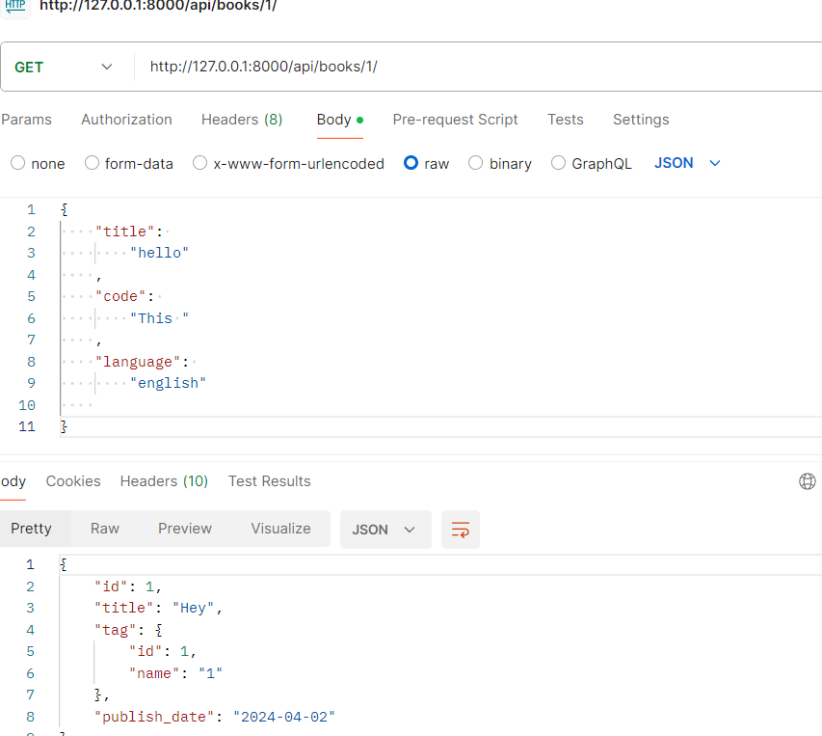

**APIVIEW:**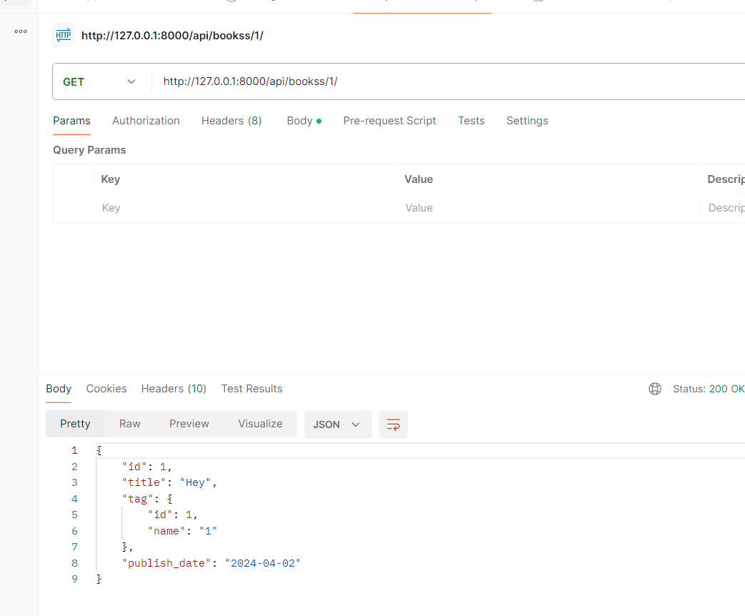

**MODELS:**

